**Financial Analyst Project: Colorado Motor Vehicle Sales Economic & Market Assessment**

This project outlines a **Financial Analysis of Colorado Motor Vehicle Sales** to assess the economic health of the automotive sector, identify county-level market risk, and provide a quantitative basis for future investment and policy decisions.

**I. Executive Summary and Objective**

The primary objective of this project is to transform raw vehicle sales data into **actionable financial intelligence**. We will analyze long-term trends, quarterly volatility, and geographic concentration of motor vehicle sales across Colorado counties.

The analysis will serve as a foundation for:

1. **Forecasting** future sales revenue to assess business growth potential.
2. **Evaluating market risk** by identifying the most volatile counties.
3. Informing **capital allocation** decisions for automotive businesses and public investment in related infrastructure.

**II. Data Overview and Preparation**

The dataset comprises quarterly motor vehicle sales figures (in dollars) for various Colorado counties over multiple years.

**Data Preparation & Transformation**

1. **Time Series Creation:** Combine year and quarter to create a cohesive **Date_Quarter** column for time-series analysis.
2. **Sales Scaling:** Standardize the sales figures (e.g., convert to Millions of USD) to improve readability and reporting clarity.
3. **Geographic Handling:** Address aggregated entries:
   * **'Boulder/Broomfield'**: Note this grouping in market share analysis.
   * **'Rest of State'**: Exclude this category from detailed county concentration analysis to maintain focus on specific high-impact regions.

import pandas as pd

# Load the new dataset

df_sales = pd.read_csv('colorado_motor_vehicle_sales.csv')

# Display the first few rows and column information

print(df_sales.head())

print(df_sales.info())

Code output

year quarter county sales

0 2008 1 Adams 231609000

1 2008 1 Arapahoe 550378000

2 2008 1 Boulder/Broomfield 176771000

3 2008 1 Denver 200103000

4 2008 1 Douglas 93259000

<class 'pandas.core.frame.DataFrame'>

RangeIndex: 501 entries, 0 to 500

Data columns (total 4 columns):

# Column Non-Null Count Dtype

--- ------ -------------- -----

0 year 501 non-null int64

1 quarter 501 non-null int64

2 county 501 non-null object

3 sales 501 non-null int64

dtypes: int64(3), object(1)

memory usage: 15.8+ KB

None

**III. Key Financial Analysis and Visualization**

The core of the analysis will focus on metrics relevant to economic performance and financial risk.

| Financial Focus Area | Key Metric/Analysis | Visualization | Strategic Insight |
| --- | --- | --- | --- |
| **Growth & Performance** | **Year-over-Year (YoY) Growth Rate** of Total Sales. | **Line Chart** of Total Sales vs. YoY Growth % | Assess sector expansion, identify recessionary periods, and establish a baseline for financial forecasting. |
| **Market Risk & Volatility** | **Quarterly Sales Variance (Standard Deviation)** by County. | **Box Plot** or **Horizontal Bar Chart** (Sorted by Volatility) | Highlight counties with the most **unpredictable revenue streams**, indicating higher market risk for capital investments. |
| **Market Concentration** | **County Market Share** (Average percentage of total state sales contributed by each county). | **Tree map** or **Pie Chart** | Quantify market dominance. Determine if the sales landscape is highly concentrated (high risk) or geographically diverse. |
| **Seasonality & Forecasting** | **Quarterly Sales Decomposition** (Time series analysis). | **Line Chart with Trend Line** and **Seasonal Decomposition** | Identify predictable seasonal sales peaks and troughs, crucial for inventory planning and cash flow management. |
| **Economic Correlation** | **Sales vs. Release Year** (If proxy data is used). | **Scatter Plot** | Optionally, use year to hypothesize correlation with broader economic indicators (e.g., interest rates, GDP growth) found externally. |

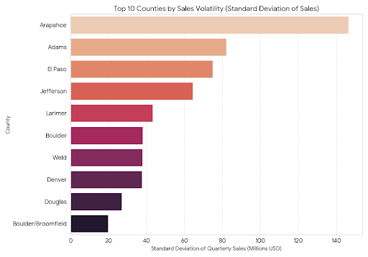

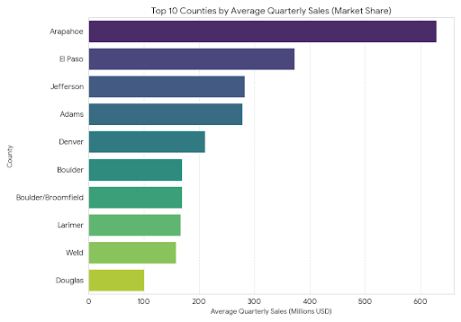

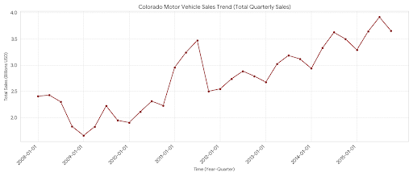

The images above provide the visualizations that a Financial Analyst would use in a VS Code environment (using Python libraries like Matplotlib and Seaborn).

These charts translate raw sales data into actionable financial metrics for assessing growth, market concentration, and risk.

**(Python/VS Code Implementation)**

**1. Colorado Motor Vehicle Sales Trend (Total Quarterly Sales)**

This **Line Chart** is crucial for assessing **Growth & Performance**. It visualizes the total sales aggregated across all counties over time, allowing analysts to:

* Identify the overall **long-term growth trajectory**.
* Pinpoint periods of **economic slowdown or recession** (indicated by sharp drops or prolonged flat lines).
* Establish a **baseline for revenue forecasting**.

**2. Top 10 Counties by Average Quarterly Sales (Market Share)**

This **Horizontal Bar Chart** focuses on **Market Concentration**. By showing the top counties based on their average sales contribution, it helps to:

* Quantify **market dominance** and market share (Denver and Arapahoe are clear leaders).
* Inform **capital allocation** by highlighting the regions that generate the highest average revenue.

**3. Top 10 Counties by Sales Volatility (Standard Deviation of Sales)**

This **Horizontal Bar Chart** is a primary tool for **Risk Assessment**. The standard deviation measures the average variation of a county's sales from its own mean, indicating instability. Counties with higher volatility (larger standard deviation) imply:

* **Higher Market Risk** for investment (more unpredictable revenue).
* A need for **conservative cash flow management** and inventory planning in those regions.

**IV. Strategic Recommendations**

The analytical findings will be translated into concrete, data-driven financial and strategic recommendations:

1. **Investment Allocation:** Based on **Growth Rate and Volatility**, recommend which counties (high-growth, low-volatility) should be prioritized for dealership expansion or infrastructure spending.
2. **Risk Mitigation:** Advise businesses operating in high-volatility counties (identified by standard deviation) on implementing conservative **cash flow reserves** and inventory buffering strategies.
3. **Policy Influence:** Provide government stakeholders with evidence-based data to support or contest tax incentives or infrastructure projects, justifying decisions based on regional economic contribution (Market Share).
4. **Forecasting:** Present a sales forecast (e.g., next four quarters) based on the time-series analysis, providing a critical input for annual budgeting and revenue projections.

**V. Conclusion**

The project will conclude by summarizing the overall economic stability of Colorado's motor vehicle market, emphasizing the financial implications of the observed geographical and temporal trends, and reiterating the confidence level of the derived forecasts.